JENIINS TASK 03
Task 1
Create one Jenkins job using the below code and create three stages:
- stage1: Git clone to download the source code.
Launch one instance
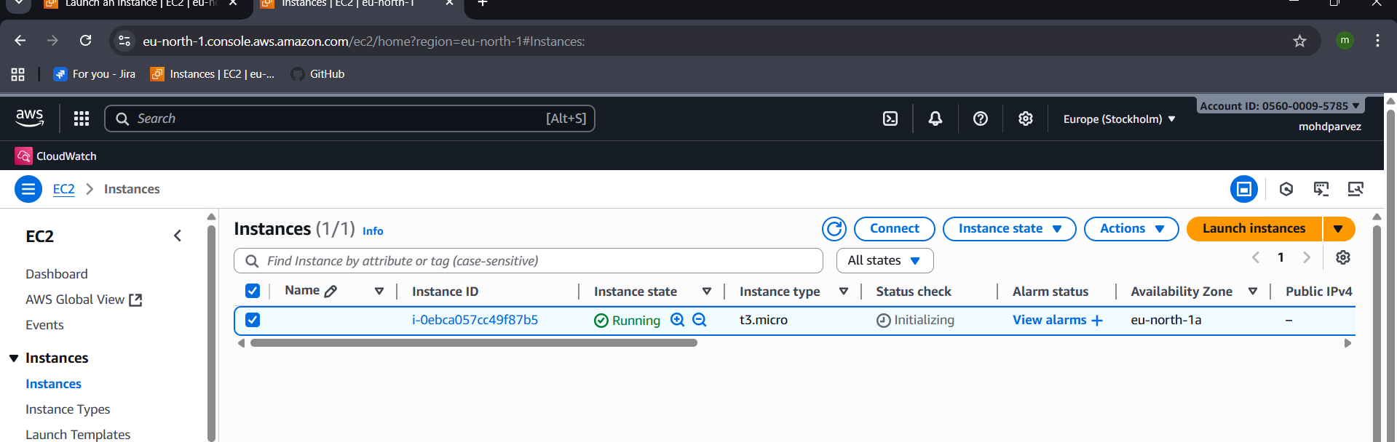
Connect and install Jenkins –
sudo wget -O /etc/yum.repos.d/jenkins.repo \
https://pkg.jenkins.io/redhat/jenkins.repo
sudo rpm --import https://pkg.jenkins.io/redhat/jenkins.io-2023.key
sudo yum upgrade
# Add required dependencies for the jenkins package
sudo yum install fontconfig java-21-openjdk
sudo yum install Jenkins
systemctl start jenkins
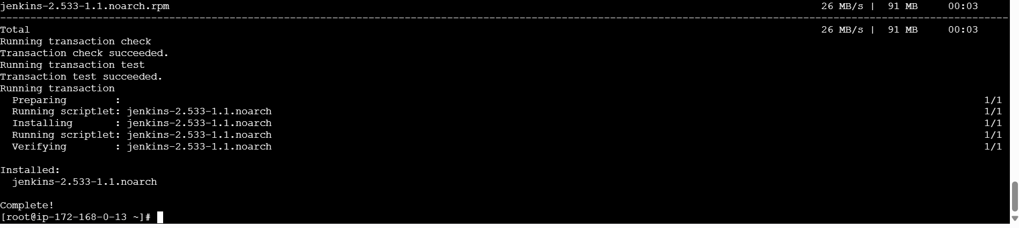
Check in the browser and login : “<ipadress>:8080(port)”
And also install git : yum install git , to clone in Jenkins

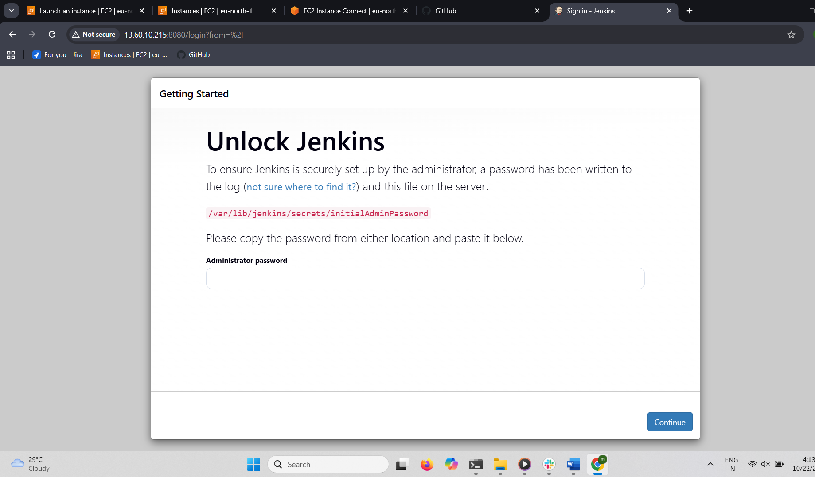
Login using password
You can find password in : cat /var/lib/jenkins/secrets/initialAdminPassword
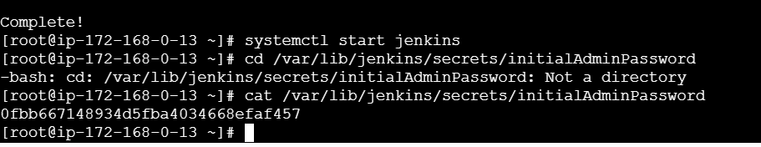
Use the password and login

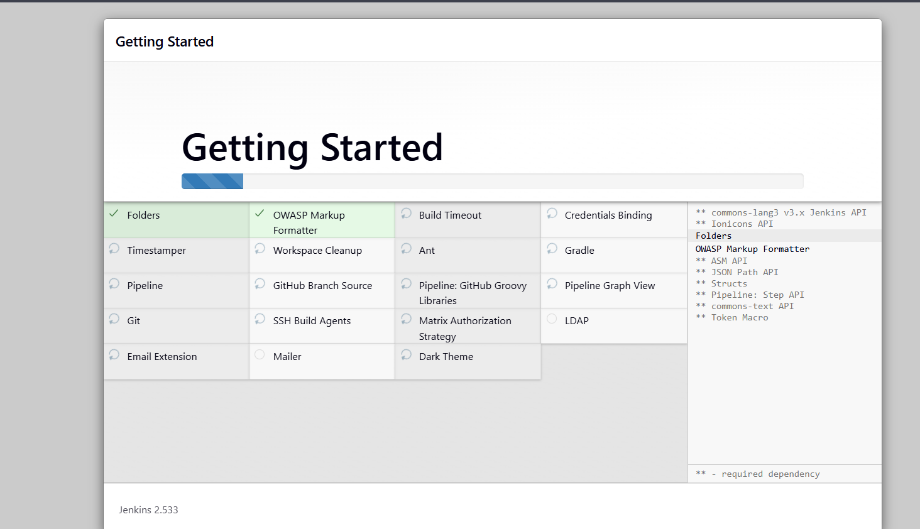after login you can see the dash board

Create new item give name freestyle project
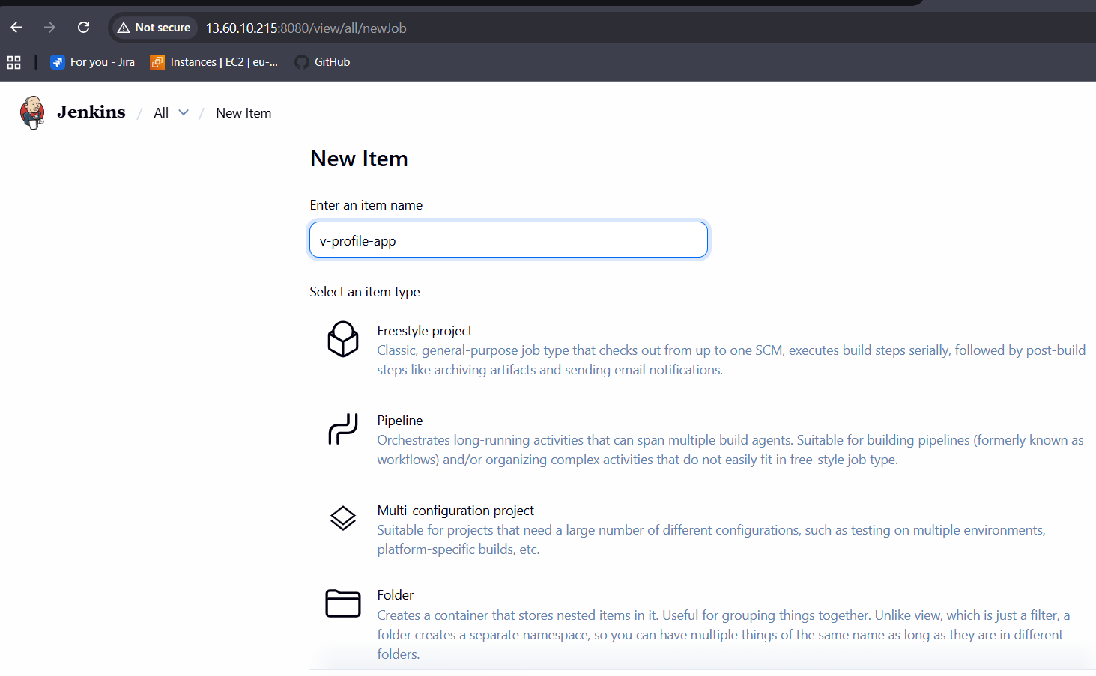
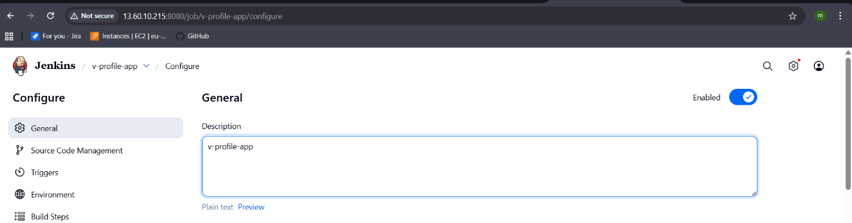
Copy the url of the source code : git hub repository url
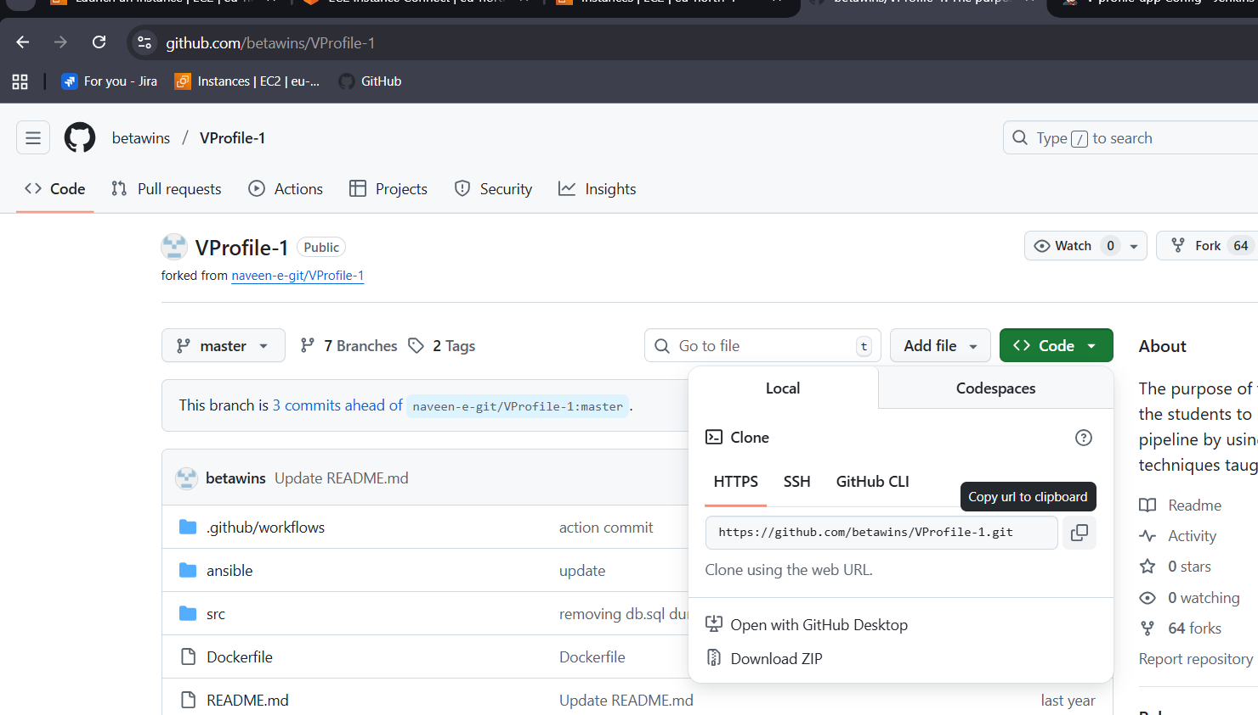
Select the source git Paste the url
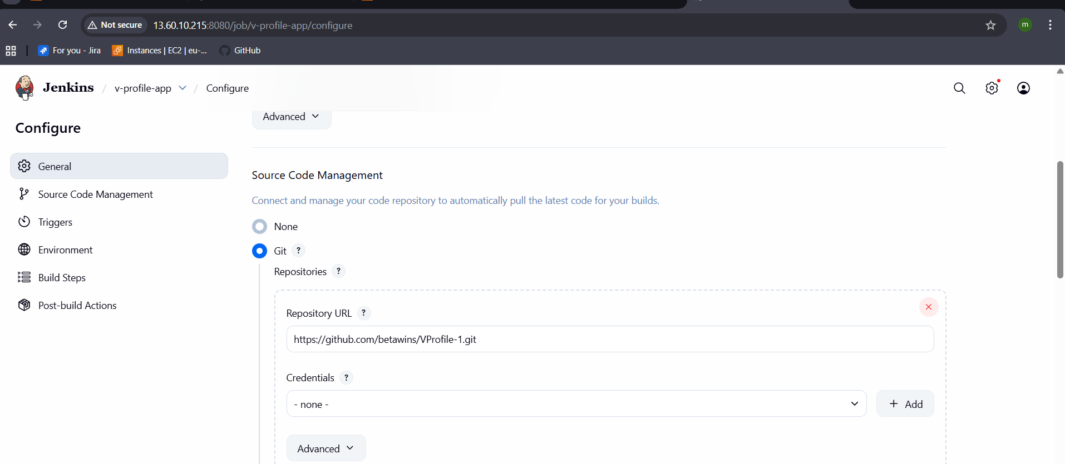
In Jenkins server CLI you can check the v-profile has been cloned from git
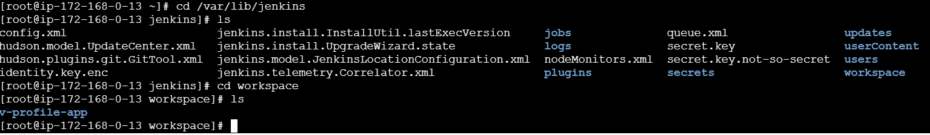
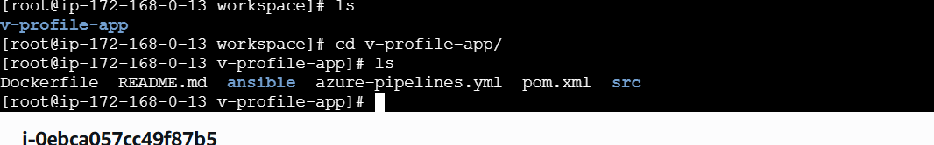

- stage2: Sonarqube Integration to check the quality of code.
Yum install docker
Systemctl start docker
docker pull sonarqube:latest
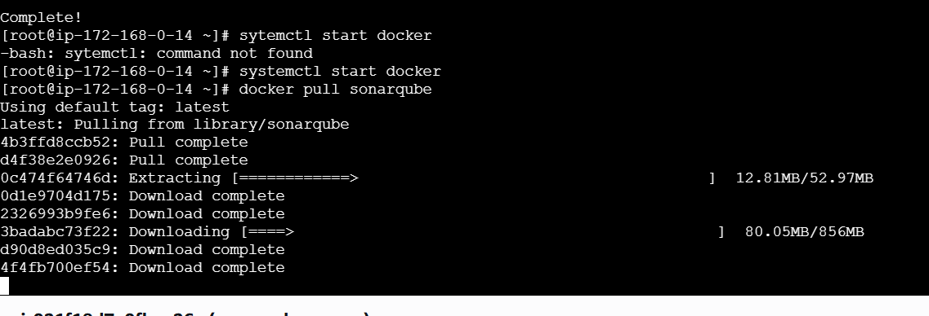
Start the sonarqube:
docker run -d --name sonarqube \
-p 9000:9000 \
-e SONAR_ES_BOOTSTRAP_CHECKS_DISABLE=true \
sonarqube:latest
For sonarqube prerequisites
- EC2 instance with Java installed
- MySQL Database Server or MyQL RDS instance
Launch instance with the t3.large and 20gb of memory
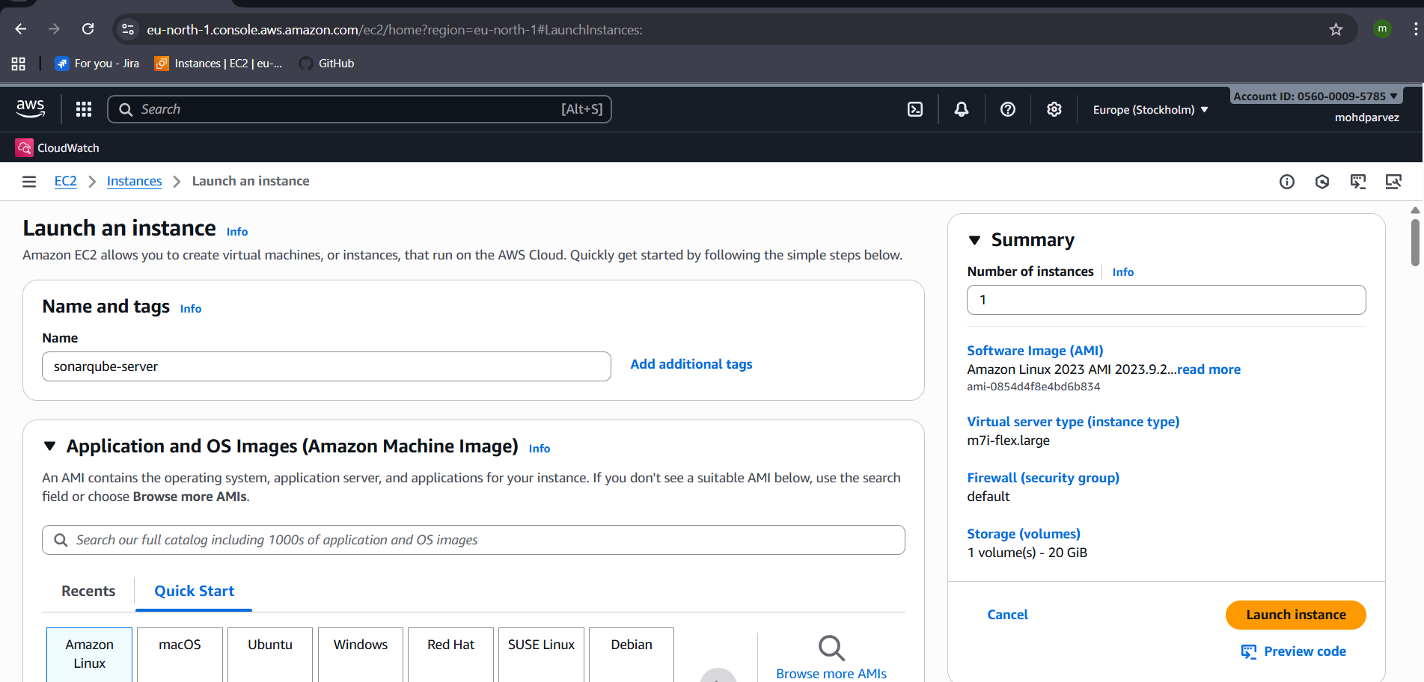
Iam using instance type m7i.flex.large as free tier eligible
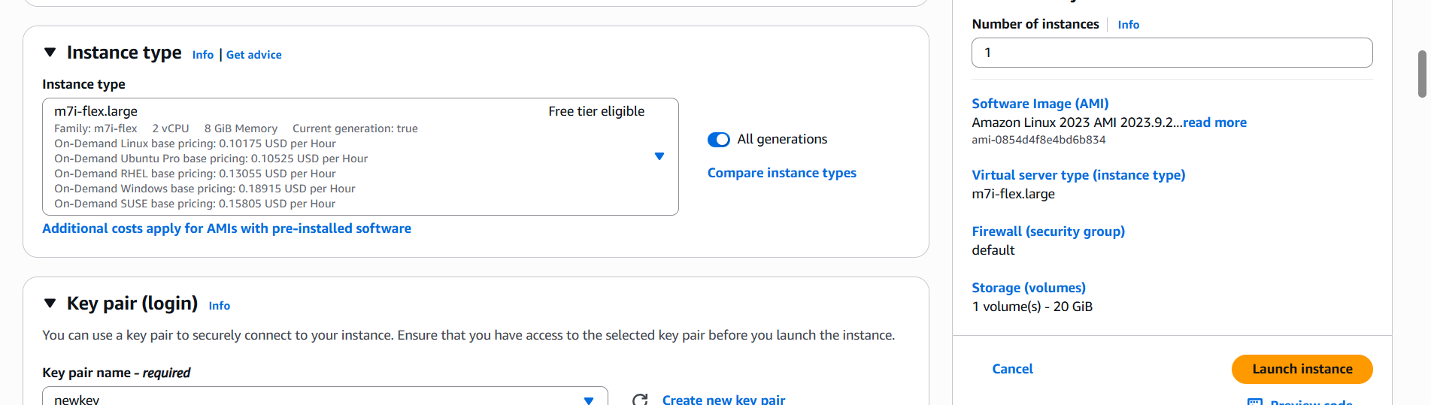
Connect to the instance and install java : yum install java-17
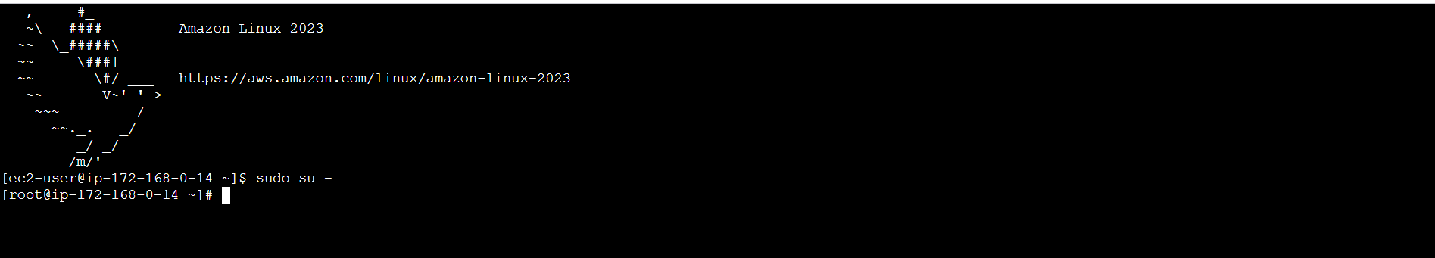
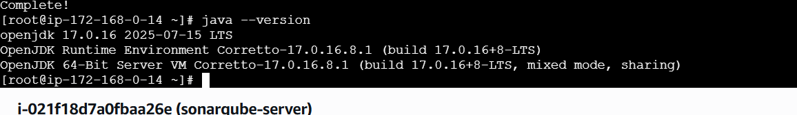
Now install sonarqube in opt directory
Cd opt/
# cd /opt
# wget https://binaries.sonarsource.com/Distribution/sonarqube/sonarqube-7.6.zip
# unzip sonarqube-7.6.zip
# mv /opt/sonarqube-7.6 /opt/sonarNow unzip the file : unzip sonarqube-25.10.0.114319.zip
Now rename the extracted file : mv sonarqube-25.10.0.114319.zip sonar
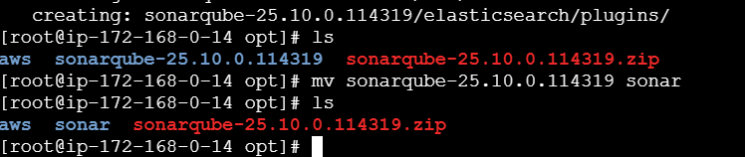
Install mysql :
sudo dnf remove mysql80-community-release
wget https://dev.mysql.com/get/mysql80-community-release-el9-1.noarch.rpm
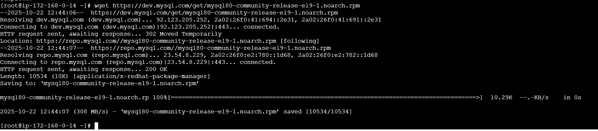
sudo dnf install mysql80-community-release-el9-1.noarch.rpm
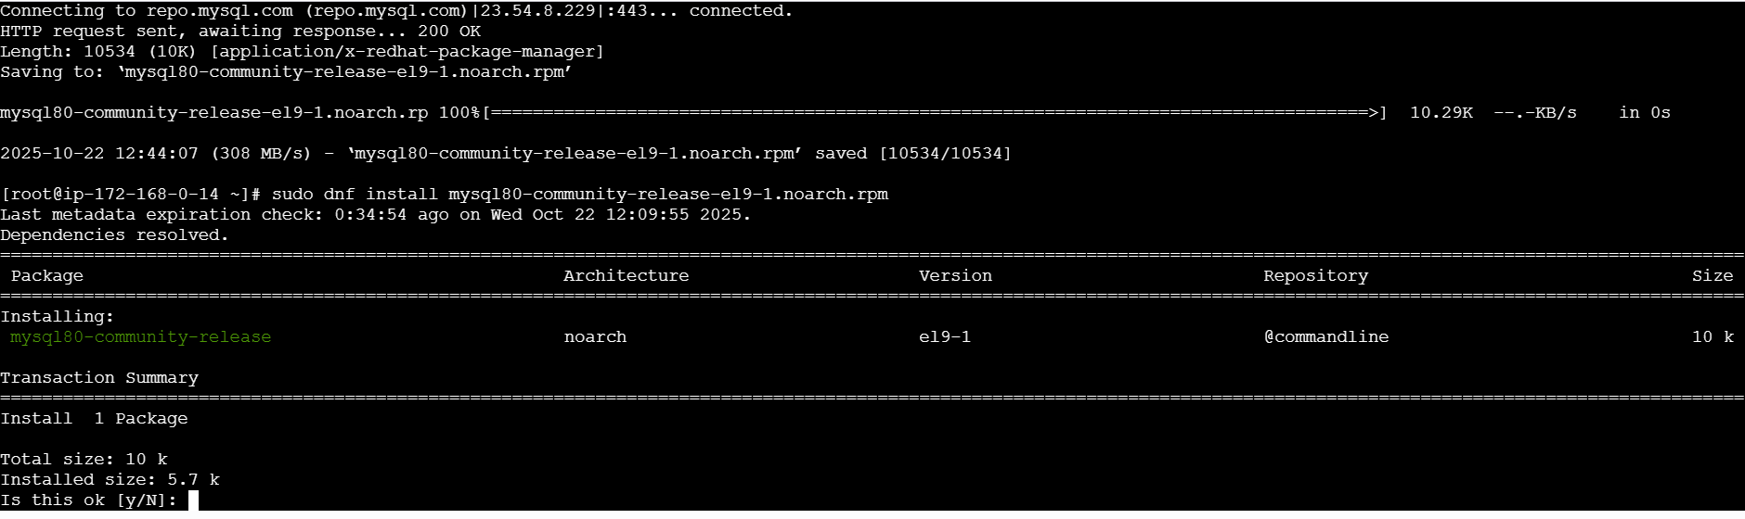
sudo rpm --import https://repo.mysql.com/RPM-GPG-KEY-mysql-2023
sudo dnf clean all
sudo dnf makecache
sudo dnf install mysql-community-server mysql-community-client
sudo systemctl enable --now mysqld
sudo systemctl status mysqld
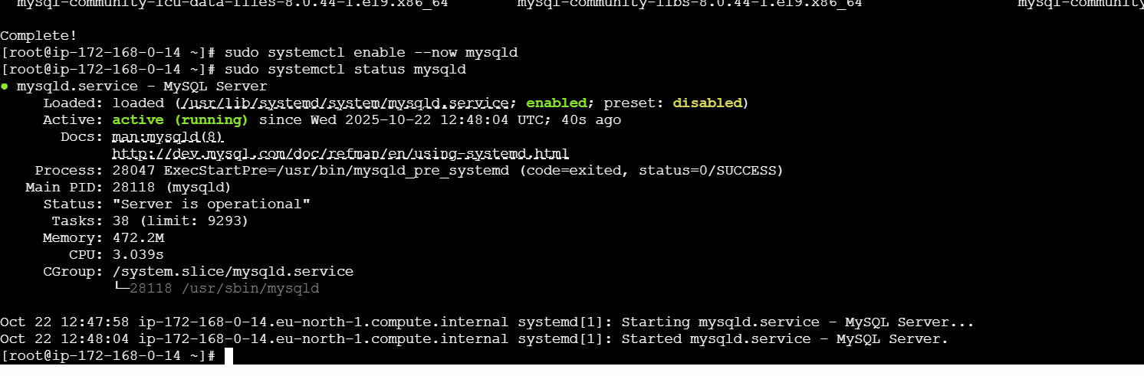
Temporary password generation : grep ‘temporary’ /var/log/mysqld.log
Login to mysql : mysql -u root -p : enter the password that will be shown
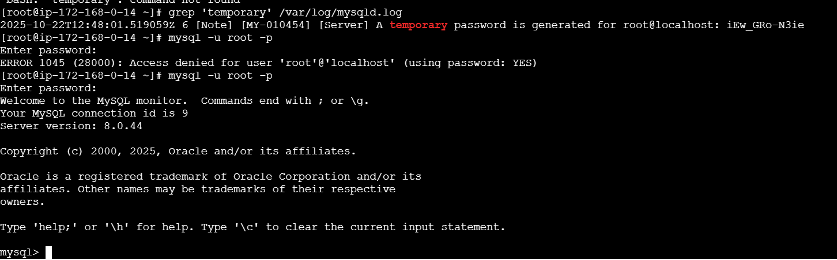
Change the password:
ALTER USER ‘root’@’localhost’ IDENTIFIED BY ‘Admin@123’;
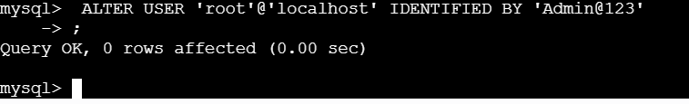
Flush privileges : for updating
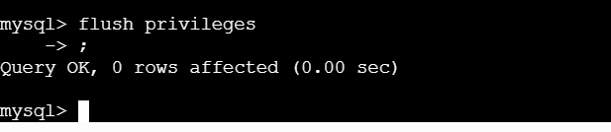
Create new database:
CREATE DATABASE sonar CHARACTER SET utf8 COLLATE utf8_general_ci:
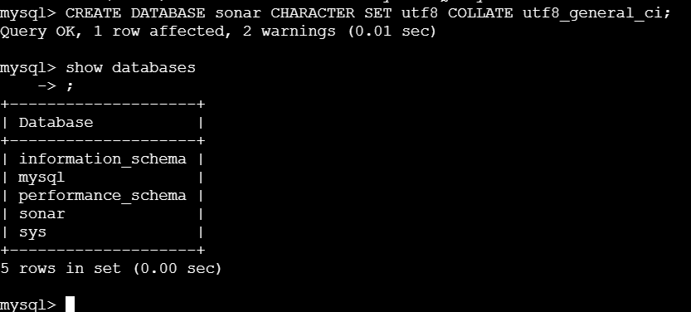

Create remote and local user:
CREATE USER sonar@localhost IDENTIFIED BY 'Sonar@123';
CREATE USER sonar@"%" IDENTIFIED BY 'Sonar@123';
Grant all permission:
GRANT ALL ON sonar.* TO sonar@localhost;
GRANT ALL ON sonar.* TO sonar@"%";
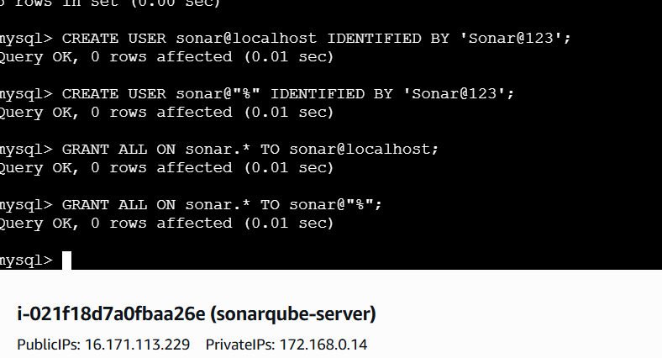

SELECT User FROM mysql.user;
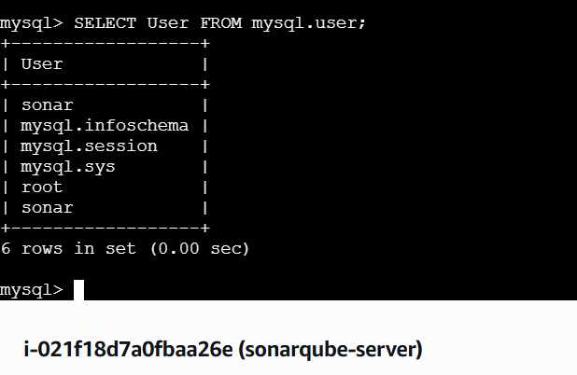
FLUSH PRIVILEGES;
QUIT;
NOW ON EC2 EDIT THE SONAR PROPERTIES
FOR SONARQUBE
Yum install docker
Systemctl start docker
docker pull sonarqube:latest

Start the sonarqube:
docker run -d --name sonarqube \
-p 9000:9000 \
-e SONAR_ES_BOOTSTRAP_CHECKS_DISABLE=true \
sonarqube:latest
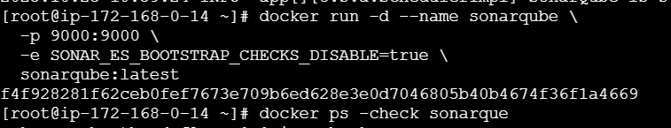

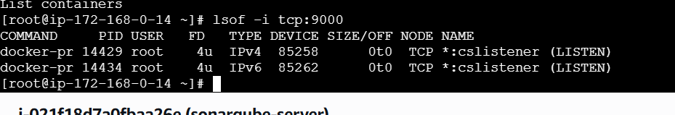
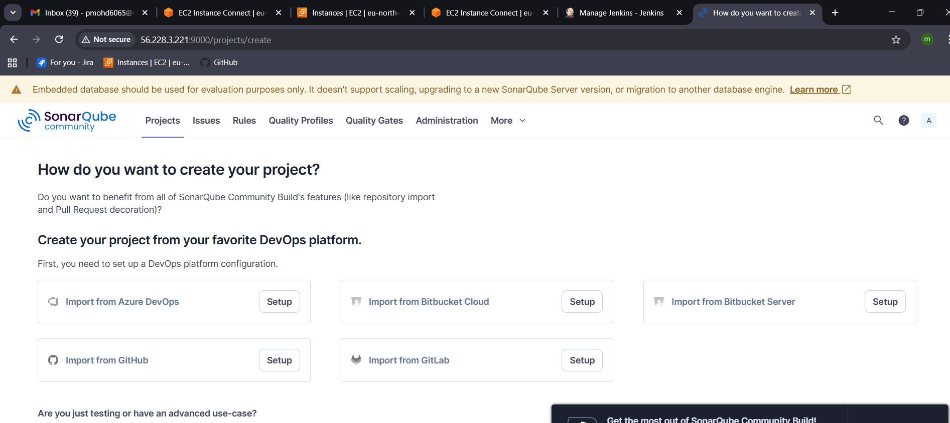
Go to Jenkins server -CLI
use
wget https://binaries.sonarsource.com/Distribution/sonar-scanner-cli/sonar-scanner-cli-4.6.2.2472-linux.zip
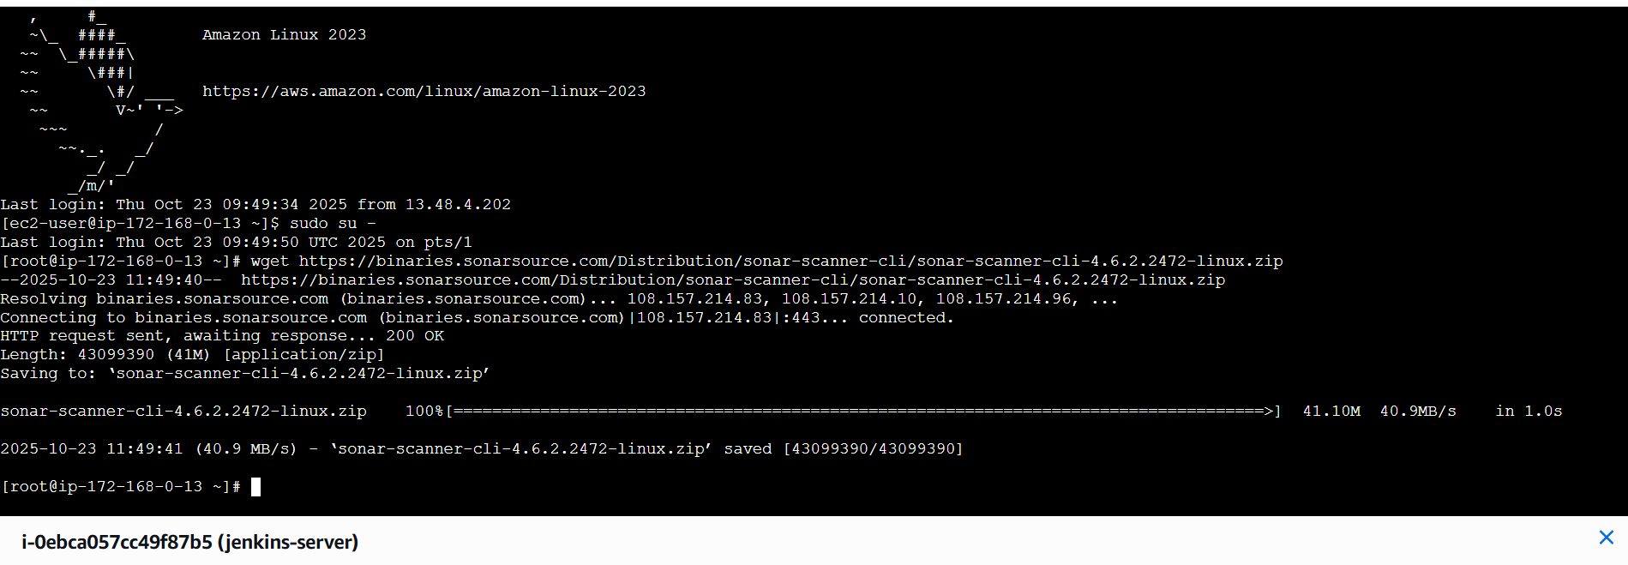

- stage3: Slack Integration to send the alerts to slack.
URL: https://github.com/betawins/VProfile-1.git

